**HIPS Guidance supporting inter- agency professional challenge and resolution**

**Working Together to Resolve Professional Differences**

**The Stages Flowchart**

**Please note timescales are indicative and it is recognised that this is dependent on the timescales dictated by the needs of the child**. **Practitioners should consider with their line manager/safeguarding leads if the needs of the child indicate more immediate resolution is required.** **It is recognised all organisational structures/roles may not be the same, please follow your organisational structure.**

Hampshire Safeguarding Children Partnership: [hscp@hants.gov.uk](mailto:hscp@hants.gov.uk), Isle of Wight Safeguarding Children Partnership: [scp@iow.gov.uk](mailto:scp@iow.gov.uk), Portsmouth Safeguarding Children Partnership: [pscp@portsmouth.gov.uk](mailto:pscp@portsmouth.gov.uk), Southampton Safeguarding Children Partnership: [Safeguarding.partnershipsteam@southampton.gov.uk](mailto:Safeguarding.partnershipsteam@southampton.gov.uk)

**Hampshire, Isle of Wight, Portsmouth and Southampton (HIPS) Procedure supporting inter- agency professional challenge and resolution**

**Working Together to Resolve Professional Differences**

**“Professional challenge should be welcomed, for the children and families we work with”**

**Multi agency practitioner 2024**

1. **Why is this important?**

Multi agency working will sometimes give rise to differences of opinion or concerns about professional safeguarding practice in relation to a child or family member. The safeguarding partners across HIPS have recognised that the needs of children and families can be complex and supporting those needs can be complicated for the multi-agency workforce. This can mean that practitioners may have differing views of what the right approach to safeguarding and promoting the wellbeing of a child should be. It may also be the case, that occasionally the needs of some children and families may not easily translate into the application of threshold criteria.

Throughout our work, the safety and wellbeing of the child is always our shared primary concern and professional disagreements must not get in the way of this. The safety and wellbeing of the child should be the binding principle of inter-agency working.

If you feel that a practitioner is not acting in the best interests of a child you have a responsibility to respectfully challenge the practitioner and if resolution cannot be achieved, to escalate your concern. Professional challenge and escalation should be viewed as a necessary part of working together to safeguard children.

All agencies working with children and families are responsible for ensuring that their staff are supported and know how to appropriately support and challenge, escalate and resolve inter agency concerns about a child and the response to their wellbeing and safeguarding needs.

While traditionally, procedures such as these have been seen and generally used to raise professional challenge in relation to the decision making of children’s social care services, this procedure is inter-agency and can be used to professionally challenge decision making and practice of any practitioner from any agency or agencies.

In resolving differences, it is essential that disagreements are approached in a considerate way, respecting and understanding the views and concerns of other practitioners.

Professional challenge has been described by the national Child Safeguarding Practice Review Panel as a “perennial practice challenge”.

In their assessment of local child safeguarding practice reviews the national Child Safeguarding Practice Review Panel highlight a lack of challenge between professionals and an apparent reluctance to escalate concerns. The national Child Safeguarding Practice Review Panel emphasise the importance of senior leaders encouraging professional challenge and modelling this as it is “essential to securing good outcomes for children”. [1]

Working Together to Safeguard Children notes that when practitioners have concerns or information about a child that may indicate a child is suffering or likely to suffer significant harm, they share them with relevant practitioners and **escalate them if necessary**, using the referral or **escalation procedure in place within their local multi-agency safeguarding arrangements.**[2]

This document, agreed by safeguarding partners across HIPS, provides that procedure for all practitioners who work with children and families across the Hampshire, Isle of Wight, Portsmouth and Southampton region.

Please note Working Together to Safeguard Children statutory guidance also requires that [Relevant Agencies](https://www.legislation.gov.uk/uksi/2018/789/made) have in place clear escalation policies for the staff to follow when their child safeguarding concerns are not being addressed within their organisation or by other multi agency practitioners.

This document is not for use where there are systemic issues nor as a replacement for agencies complaints processes.

1. **When to use this procedure**

**3. Resolving professional differences stages**

3.1 An overview.

|  |  |  |  |  |
| --- | --- | --- | --- | --- |
| **Stage 1** | **Stage 2** | **Stage 3** | **Stage 4** | **Stage 5** |
| Any practitioner who disagrees with a decision should discuss this issue with their line manager/safeguarding lead to clarify their thinking and reflect on their views | Discussion between practitioners from different agencies to work together to resolve their differences | Escalation to line manager level if resolution not achieved. Line managers to discuss the matter and work together to resolve the differences | Escalation to head of service level if resolution not achieved. Heads of service to discuss and work together to resolve the differences | Escalation to Local Safeguard Children Partnership, contacting the relevant LSCP team. This will ensure a resolution meeting for the relevant LSCP members. |
| Timescale  Two working days | Timescale  Two working days | Timescale  Two working days | Timescale  Two working days | Timescale  Two working days |

* 1. The Stages

**Please note timescales are indicative and it is recognised that this is dependent on the timescales dictated by the needs of the child**. **Practitioners should consider with their line manager/safeguarding leads if the needs of the child indicate more immediate resolution is required.** **It is recognised all organisational structures/roles may not be the same, please follow your organisational structure.**

**Stage 1**. Discussion with line manager/safeguarding lead.

This is to clarify your thinking and access support regarding any need to escalate a concern. **A template is available to help structure/consider your concerns.**

Any practitioner who disagrees with a decision should initially discuss the issue with their line manager/safeguarding lead to clarify their thinking, to identify the problem, the potential impact on the child and be able to specify what the disagreement is about.

This discussion may help clarify the issues at this stage so that the professional in question no longer disagrees with the decision made by the other professional.

The discussion should take place within two working days from when the disagreement or concern arose.

Discussion and communication should be documented at this and every stage.

**Stage 2** – Inter-agency discussion.

This is a discussion between the two people who disagree to resolve the issue. This should take place as soon as possible and could be a telephone conversation, video call or face to face meeting. Remember

1. Relationships are central to effective working
2. Everyone’s voices should be heard and valued
3. Problem-solving should be collaborative
4. Accountability and responsibility lead to change, learning and better outcomes for children.

Most disagreements can be resolved at this stage by having a discussion about the difference of opinion and the thinking of each practitioner. These discussions should be conducted in a relational manner. At all times the needs of the child should be paramount. Discussion and communication should be documented.

Every effort should be made for this discussion to take place within two working days of the completion of stage 1.

**Stage 3** Line Manager/Safeguarding Lead Inter-agency discussion

If the issue is not resolved the practitioner should advise their line manager/safeguarding lead who will then have a discussion with their equivalent in the other agency.

In most cases the relevant line managers will be able to resolve the disagreement between them.

Line managers will be able to review the available information and generally will be able to resolve the concern. Any action agreed should be fed back immediately to the relevant practitioners and the detail of the escalation and resolution agreements reached should be recorded on the child’s file.

 Every effort should be made for this discussion to take place within two working days of the completion of stage 2.

**Stage 4** Head/Director of Service Inter-agency discussion.

Where it is not possible to resolve the disagreement at earlier stages the matter should be referred without delay to Heads/Directors of Service.

They will review the available information and will generally be able to resolve the concern. Any action agreed should be fed back immediately to the relevant practitioners and the detail of the escalation and resolution agreements reached should be recorded on the child’s file.

The purpose of escalating the dispute to this level is to reach a position where differing professional opinions have been taken into account and efforts made to explore whether the dispute has arisen through lack of clarity or understanding between professionals. It is an expected outcome that agencies agree a way forward reflecting the needs of the child.

 Every effort should be made for this discussion to take place within two working days of the completion of stage 3.

**Stage 5** Partnership Member Inter-agency discussion

If it has not been possible to resolve the professional differences within the agencies concerned then this should be referred by the concerned agency to the local safeguarding children partnership (LSCP), who will arrange a resolution meeting with relevant partnership members and the independent scrutineer or partnership chair.

In the unlikely event that the professional disagreement remains, the disagreement should be escalated to the Partnership Manager at the relevant LSCP to seek an inter-agency resolution. This can be done by the agency raising the issue/concern e-mailing the details through to the relevant LSCP setting out the actions taken to date and the rationale for the involvement of the LSCP.

The Partnership Manager will then make contact with the members who represents the organisations on the Partnership Board or its Executive Group to seek resolution.  The learning from this resolution meeting or review will be disseminated to all parties within one month of the meeting or review.

Any action agreed should be fed back immediately to the Directors/Heads of Service involved with details of the agreements reached.

Every effort should be made for the email to be sent to the LSCP **within two working days of the completion of stage 4**.

**Contact details LSCPs**

|  |  |
| --- | --- |
| Hampshire Safeguarding Children Partnership  [hscp@hants.gov.uk](mailto:hscp@hants.gov.uk) | Isle of Wight Safeguarding Children Partnership  [scp@iow.gov.uk](mailto:scp@iow.gov.uk) |
| Portsmouth Safeguarding Children Partnership  [pscp@portsmouth.gov.uk](mailto:pscp@portsmouth.gov.uk) | Southampton Safeguarding Children Partnership  [Safeguarding.partnershipsteam@southampton.gov.uk](mailto:Safeguarding.partnershipsteam@southampton.gov.uk) |

**Please be reminded that timescales are indicative and it is recognised that this is dependent on the timescales dictated by the needs of the child**. **Practitioners should consider with their line manager/safeguarding leads if the needs of the child indicate more immediate resolution is required.**

1. **Template to Consider/Structure Your Concerns**

|  |
| --- |
| **Template: Structuring your concerns -Resolving Professional Differences Together** |
| What is the decision or practice that is of concern and why? |
|  |
| What impact is this likely to have on the child/ren? And why? Are there factors that might mitigate? |
|  |
| What are indicators of need/risk for the child considering the threshold guidance for the local area? |
|  |
| Has all relevant information been shared with the decision maker? |
|  |
| Is there any additional information that is needed? The roles and responsibilities of an agency, the criteria for a service for example? Who can support you in finding this information? |
|  |
| What are the outcomes you are seeking for the child? |
|  |
| What are your next steps |
|  |

1. **Prompts to support relational conversations.**

The values underpinning these discussions are respect, responsibility and relationships. It’s about building and maintaining working relationships. Relational approaches use language that is inclusive, emotionally intelligent and is solution-focussed on the issue rather than the person.

Remember to be brave and courageous yet respectful in professional challenge and resolution.

Set a clear and shared expectation for everyone to be open, to actively listen and understand professional worries.

Remember to remain clear and factual.

Validate differences and difficulties within each agency/profession.

Remember to be curious and to listen to hear, rather than to respond, take the conversation slowly.

|  |  |
| --- | --- |
| **What happened?** | * What are your concerns? * Tell me about your thinking? * Tell me more about… * At that point, what were you thinking/feeling? * Do you have any other comments to make/ anything you would like to add? * Has anything happened since the disagreement that needs to be shared? * Would you like to share information about your role, would you like to know more about mine? |
| **Impact** | * Has the child been affected? * How have they been affected? * How might they be affected? * Has anyone else been affected? Who? What has been the impact on them? * How do you feel about it now? * Have you got anything else to add? * Tell me more about… |
| **What needs to happen now** | * What needs to happen next? * What would that look like? * When does this need to happen? * What support might be needed to make this happen? * What else needs to happen? * What do you think about what has been suggested? * How does that leave you feeling? * How will we know that what we have agreed will happen, has happened? * Are you okay with that? * Do we all agree that…? * Anything else to add? * What have we learned? * If this happens again, what will we do differently? |
| **Plan to follow-up – When will be a good time to check in together to see how the plan is moving on.** | |

1. **Our shared aims**

To ensure the needs of the child first and foremost and family are at the centre of all your professional discussions.

To ensure professional disagreements are resolved at the earliest stage and between practitioners working with the child and family wherever possible (lowest level)

To recognise that children are most effectively safeguarded, and their welfare promoted when practitioners who support them and their families work well together. This means that your actions are co-ordinated and your communication is timely, respectful, solution focussed and child centred.

To provide a process to support professional challenge and resolution for all multi agency working relating to safeguarding and promoting the welfare of children.

To ensure senior leaders and managers in organisations are aware of and acting on their responsibility to support their staff to appropriately engage in professional challenge and raise awareness of this procedure

1. **Our agreed purpose of this procedure**

* To have a transparent process that sets out how disagreements about the effective safeguarding of children should be resolved between multi-agency professionals.
* To ensure disagreements are resolved quickly through child centred discussions
* To ensure that resolution is found by escalating concerns where necessary in a supportive, respectful and timely way.
* To ensure that disagreements do not detract from the needs or risks to the child, delay decision making or lead to protracted disagreements that can impact negatively on the child and family, on multi agency working relationships and safeguarding practice.
* To ensure there is effective professional challenge regarding the application of thresholds for services. We understand that children do not always neatly fit into threshold criteria for services and sometimes this can benefit from debate and discussion.

1. **Our shared commitment**

Your local safeguarding partners have agreed that we share the following commitments.

* All multi agency practitioners will work to resolve professional differences at the earliest stage and in a timely way.
* We will model effective practice in working with families, offering each other high support, and high challenge, being child centred, professionally curious and being solution focussed.
* At any and all stages of this resolution process, relevant actions and decisions must be shared with appropriate practitioners working with the child and family.
* Decisions should be recorded and the practitioner raising the professional challenge should be kept informed of the progress of their concern. This includes recorded confirmation between practitioners of the outcome of the resolution process and any action required. These records should be retained according to the relevant agencies recording policy and procedure.
* Resolution should be sought within the shortest timescale possible to ensure the child is safeguarded. It is recognised that some disagreements about the effective safeguarding of a child may require more immediate resolution.
* All practitioners agree to facilitate use of this procedure even when they do not agree use of this procedure is necessary.

1. **What effective professional challenge looks like – our multi agency expectations**

Working Together to Safeguard Children details multi agency expectations. In relation to this procedure the following are relevant and endorsed by the LSCPs across the HIPS region.

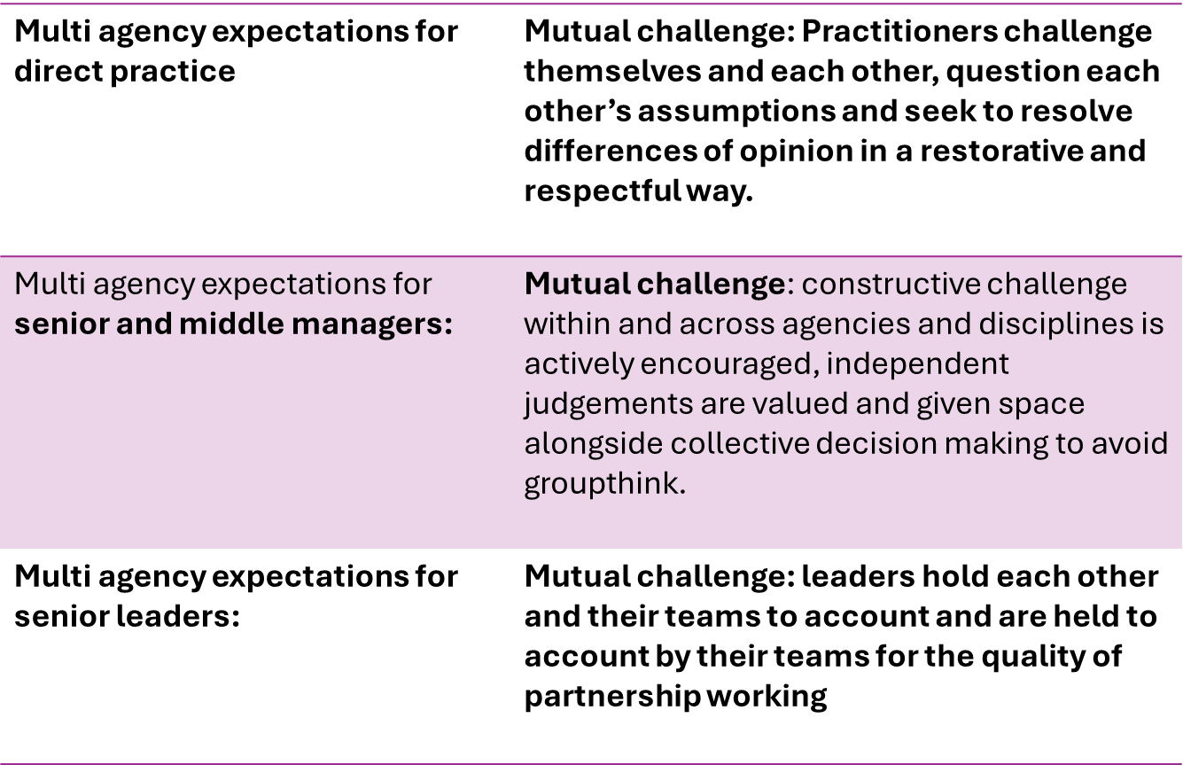

We share a clear expectation that professional challenge and escalation will be approached in a restorative and respectful way. This means we follow the research-based principles of restorative practice as follows:

1. Relationships are central to effective working
2. Everyone’s voices should be heard and valued
3. Problem-solving should be collaborative
4. Accountability and responsibility lead to change and learning.

This will be reflected in how we approach and support each other in the use of this procedure.

When we need to escalate a concern, we will be prepared to share the concern in a constructive way.

We will have considered the issue/concern and identified:

* What is the decision or practice that is of concern and why?
* What impact is this likely to have on the child/ren? And why? Are there factors that might mitigate?
* The indicators of need/risk for the child considering the threshold guidance for the local area?
* That all relevant information has been shared with the decision maker?
* If there is any additional information that is needed? The roles and responsibilities of an agency, the criteria for a service for example?
* The outcomes that are sought for the child?

These areas are included in a template to support practitioners in discussing and reflecting on their concerns. See Appendix 1.

1. **Top Tips- Effective practice in embedding in organisations.**

* Highlight this procedure in all single agency safeguarding training.
* Make a link to the procedure available internally for your colleagues.
* Link the procedure within your agency safeguarding procedure/policy.
* Discuss the procedure within relevant team meetings/staff briefings/supervision and one to one meetings.
* When the procedure is used have a feedback mechanism internally to determine effective use, impact and share learning.
* Use the annual self-assessment process (S11 or S175/157) to assure your agency of how this procedure is used and known about within your agency.
* Don’t do these things once!

**Appendix 1: Resources that may also support you.**

[Rethink](https://www.portsmouthscp.org.uk/7-information-for-professionals-and-volunteers/7-21-resolving-professional-differences-re-think-and-escalation/) – Portsmouth Safeguarding Children Partnership

Reflecting Teams – Southampton Safeguarding Children Partnership

[Professionals Meetings Guidance](https://www.hampshirescp.org.uk/wp-content/uploads/2022/04/Professionals-Meeting-Guidance-January-2021.pdf) - Hampshire Safeguarding Children Partnership

[Professionals Meetings Guidance](https://view.officeapps.live.com/op/view.aspx?src=https%3A%2F%2Fsecure.toolkitfiles.co.uk%2Fclients%2F25263%2Fsitedata%2FDocuments%2FProfessionals-Meeting-Guidance.docx&wdOrigin=BROWSELINK) – Isle of Wight Safeguarding Children Partnership.

Seek support from your line manager, safeguarding lead within your organisation to use a collaborative safeguarding approach to professional challenge and the resolution of professional differences.

Please note professional challenge within child protection conferences is part of HIPS procedures regarding child protection conferences.

1. [The Child Safeguarding Practice Review Panel Annual Report 2022-23 (publishing.service.gov.uk)](https://assets.publishing.service.gov.uk/media/65bce1df7042820013752116/Child_Safeguarding_Review_Panel_annual_report_2022_to_2023.pdf) page 60
2. [Working together to safeguard children: statutory guidance (publishing.service.gov.uk)](https://assets.publishing.service.gov.uk/media/65cb4349a7ded0000c79e4e1/Working_together_to_safeguard_children_2023_-_statutory_guidance.pdf) page 82