One Minute Guide
HIPS Unborn / Newborn Baby Protocol

The HIPS Unborn/ Newborn Baby Safeguarding Protocol has been in place since 2011. It responds to the recommendation in The National Service Framework for Children Young People and Maternity Services (2004) that Maternity Services and Children's Social Care (CSC) have joint working arrangements in place to respond to concerns about the welfare of an unborn baby and his/her future, due to the impact of parents' needs and circumstances.
The unborn/new born baby protocol has undergone significant review for 2021 and a number of tools have been either revised or developed to support practitioners. These include;
- Introduction of Multi-agency Concealed Pregnancy Guidance
- An information sharing flowchart and form
- A number of revised interactive Risk Assessment Pathways
- A revised pre and post birth plan template
- A parenting observation tool

Why is it important?
This multi-agency protocol sets out how to respond to concerns for unborn babies, with an emphasis on clear and regular communications between professionals working with the person who has given birth to the baby and their family where risk is identified.
Unlike many safeguarding situations the antenatal period gives a window of opportunity before the baby arrives for practitioners and families to work together to:
- Form relationships
- To identify protective factors as well as risk and vulnerabilities
- To agree a multi-agency safety planning for the unborn / newborn baby.
This protocol provides a robust framework for responding to safeguarding concerns and safety planning by practitioners working together, with families, to safeguard the baby before, during and following birth. This protocol applies across Hampshire Isle of Wight, Portsmouth and Southampton.
How do we do it?
Health Care Staff (Midwifes, Health Visitors, Family Nurses and primary care/GP's) have a role to identify pregnant women where there are existing risk factors that may impact upon the wellbeing of their unborn/ newborn baby. Health's role within this protocol is to share information, risk assessment and planning with key agencies for the pregnancy and the immediate post-natal period. Health will make a referral to MASH about unborn babies who may need services when the mother is 12/40 weeks gestation (or as soon as concerns have been identified).
The protocol aims to provide specific guidance in relation to the roles of other professionals where required, including Police and Education colleagues.

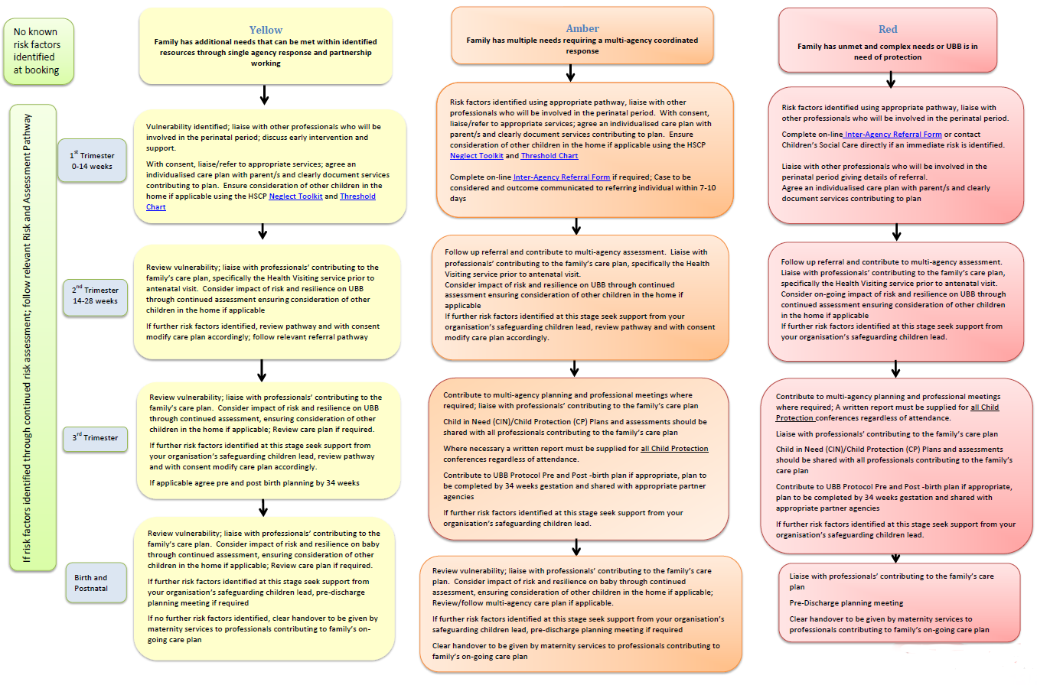
UBB Risk Assessment Pathways – Pregnancy identified: Refer to Maternity Services

MASH will notify Health of the outcome of the contact within 3 working days. In cases which have been agreed where the threshold has been met for Children's Social Care involvement, an assessment will be carried out by a social worker to work with the family and professionals to assess and plan for the unborn/ newborn baby.
Where an ICPC is required, this should be convened between 24/40 to 28/40 weeks gestation (or as soon as appropriate once pregnancy is known).
A multi-agency pre/post birth safeguarding plan must be created by 34/40 weeks gestation (or as soon as appropriate) which is the responsibility of the Lead Professional. Where there are concerns about a family irrespective of whether the unborn baby is subject to a child protection plan, a multi-agency pre/post birth safeguarding plan must be created and reviewed within timescales.
To ensure all professionals and parents fully understand the arrangements of the multi-agency safeguarding plan for unborn/ newborn babies we must be careful to use common language and avoid any jargon and professional terminology.
A template for the multi-agency pre/post birth safeguarding plan can be found at Appendix 6 of the protocol, which needs to be completed in conjunction with relevant family members and all professionals involved.
For more information:
Please refer to section 3.16 of the Hampshire, Isle of Wight, Portsmouth and Southampton (HIPS) Safeguarding Children Procedures Manual, where you can find the Unborn / Newborn Baby Safeguarding Protocol and the accompanying Risk Assessment Pathways Tool. All of this can be found here

